***Chemistry***

**12: Kinetics**

**12.7: Catalysis**

77. Account for the increase in reaction rate brought about by a catalyst.

Solution

The general mode of action for a catalyst is to provide a mechanism by which the reactants can unite more readily by taking a path with a lower reaction energy. The rates of both the forward and the reverse reactions are increased, leading to a faster achievement of equilibrium.

79. Consider this scenario and answer the following questions: Chlorine atoms resulting from decomposition of chlorofluoromethanes, such as CCl2F2, catalyze the decomposition of ozone in the atmosphere. One simplified mechanism for the decomposition is:



(a) Explain why chlorine atoms are catalysts in the gas-phase transformation:



(b) Nitric oxide is also involved in the decomposition of ozone by the mechanism:



Is NO a catalyst for the decomposition? Explain your answer.

Solution

a) Chlorine atoms are a catalyst because they react in the second step but are regenerated in the third step. Thus, they are not used up, which is a characteristic of catalysts. (b) NO is a catalyst for the same reason as in part (a).

81. For each of the following pairs of reaction diagrams, identify which of the pairs is catalyzed:

(a)

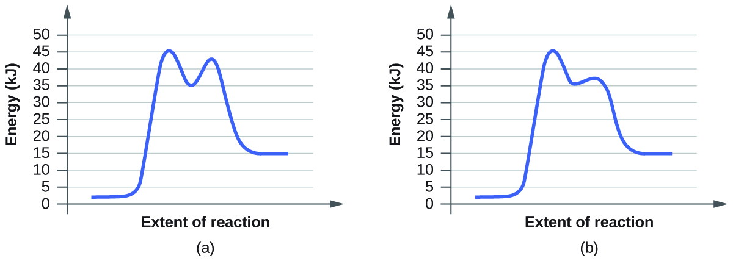

(b)

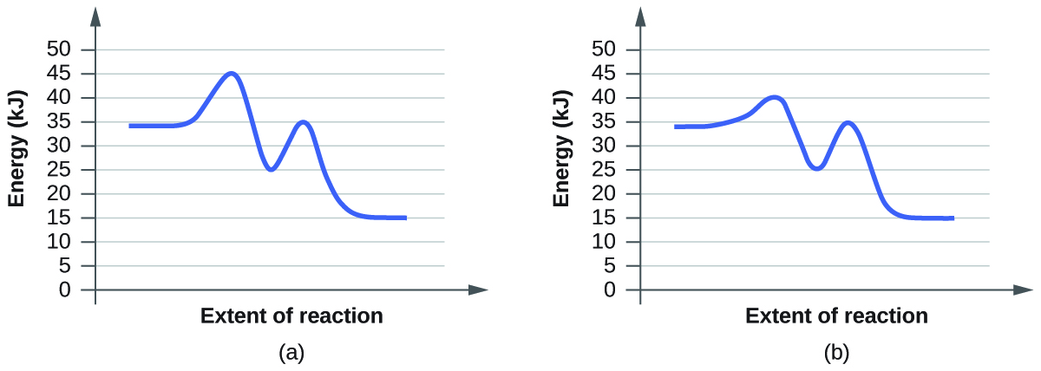

Solution

lowering of the transition state energy indicates the effect of a catalyst. (a) b; (b) b

83. For each of the following reaction diagrams, estimate the activation energy (*E*a) of the reaction:

(a)

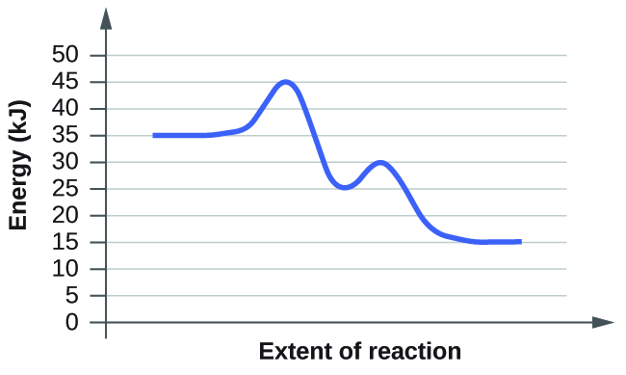

(b)

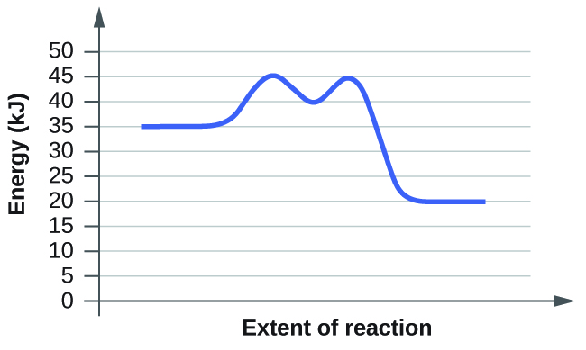

Solution

the energy needed to go from the initial state to the transition state is (a) 10 kJ; (b) 10kJ

85. Based on the diagrams in Exercise 12.83, which of the reactions has the fastest rate? Which has the slowest rate?

Solution

The smaller the activation energy, the faster the reaction. In this case, both have the same activation energy, so they would have the same rate.

This resource file is copyright 2015, Rice University. All Rights Reserved.